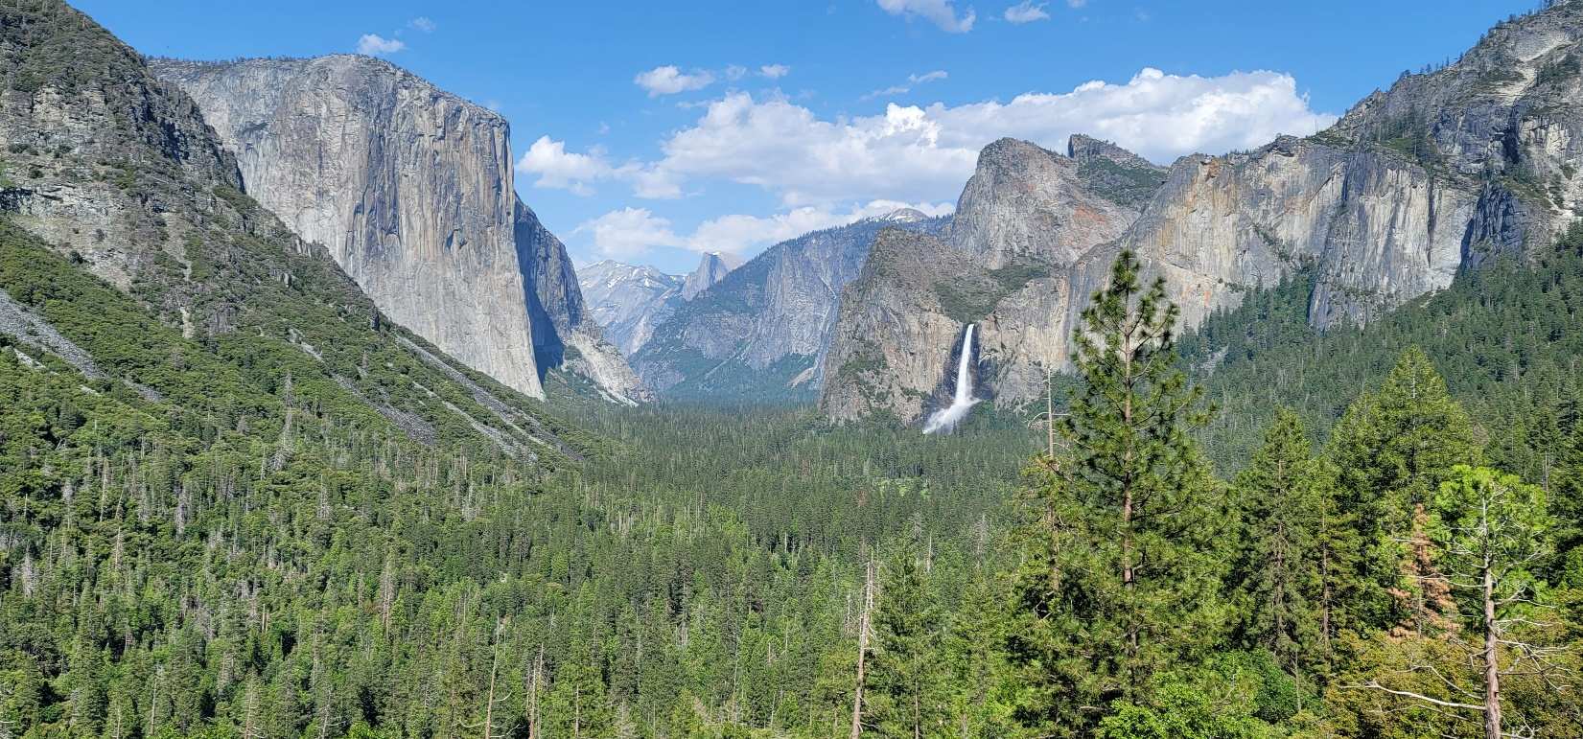
2025 Yosemite – Kootzagwae (Mono Lake Area) Traditional Walk
July 27 - August 2, 2025
Please take the time to read the enclosed information thoroughly and fill out all forms completely and legibly. Your careful attention will ensure a prompt response and less confusion by all. Plan your trip well in advance. Estimates vary, but some say the length of the Traditional Route is about 50 miles, others say it is 60 miles. We walk an average of 10 miles per day. Adequate planning will ensure you have a wonderful experience. Decide your means of transportation and the route you will take to arrive at our meeting place at the Yosemite Indian Village and how you will depart from our destination location at the Walker Lake Trailhead Campground. Maps and information on the destination location are provided in this packet.
Everyone is expected to contribute to making the Traditional Walk a success. Please let us know what you can do to help or teach. Guidelines have been set up to make the Traditional Walk more enjoyable. These will be thoroughly discussed at an orientation, July 18, and 25, 2025, for all those participating in the Traditional Walk.
Youth supervision and responsibility for minors is a major concern. Please note that you may bring as many of your own children as you wish, but if you are bringing someone else’s child, there must be no more than 2 youth to each adult chaperone.
The registration deadline for the Traditional Walk will be Wednesday July 25, 2025.
Registration packets must be returned to:
Mono Lake-Yosemite Traditional Walk Committee
P. O. Box 237
Lee Vining, CA 93541

Important Dates
July 25, 2025 – Registration Deadline
July 18, and 25, 2025 – Mandatory Virtual Orientations at 1:00 pm Pacific Time. A link will be sent to all those who submit registration forms. You may choose to attend any day but must attend one of the days.
July 26-27, 2025 – Kootzaduka’a Days Celebration at the Mono Lake Park. Join us if you want to come early and get acclimated to our high elevation and thin mountain air. Food, water, and camping space are provided. Parking space is available if you would like to leave your car at the Tribal Building and then carpool into Yosemite Valley.
++++++++++++++++++++++++++++++++++++++++++++++++++++++++++++++++++++++++++++++++++++++++++
July 27 – August 2, 2025 Traditional Walk: Yosemite Valley to Kootzagwae (Mono Lake Area).

Sunday, July 27 – Arrive and camp in Yosemite Valley Indian Village. Dinner will be provided followed by discussions on safety, respect for each other and the trail, formation of walking groups, and other preparations. Quiet hours start at 10:00 pm so that everyone sleeps well.
Monday, July 28 – Wake up at 4:30 am, pack up hiking gear, grab sack breakfast and lunch and be prepared to start on the trail with your walking group at 5:15 am. We must leave early as the hike up the Snow Creek Trail is strenuous and hot due to exposure to the south. There are some shade trees, but it is mostly open. We will have lunch along the trail, arrive at the Snow Creek Campground, and camp. Pack mules will bring dinner and other items to the camp. Traditional education/sharing during the evening. Quiet hours start at 10:00 pm so that everyone sleeps well.
Tuesday, July 29 – Wake up at 6:00 am, pack up hiking gear, grab sack breakfast and lunch and be prepared to start on the trail with your walking group at 7:00 am. The trail is mostly level with some hills, which will be welcomed after the strenuous hike up Snow Creek Trail the previous day. After breakfast, any leftover food and other items must be packed up for the mules which will return later in the morning, after we leave, to bring the items to our next camping spot at Tenaya Lake. Tribal community members and elders join us at Tenaya Lake. Dinner followed by traditional education/sharing during the evening. Quiet hours start at 10:00 pm so that everyone sleeps well.
Wednesday, July 30 – Rest Day at Tenaya Lake. Greet the sun along the shore of Tenaya Lake. Enjoy the day with each other and with our visiting tribal community. Trading event in the evening and Sweat Lodge may be available. Quiet hours start at 10:00 pm so that everyone sleeps well.
Thursday, July 31-- Wake up at 6:00 am, pack up hiking gear, grab sack breakfast and lunch and then start on the trail with your walking group by 7:00 am. The trail is uphill and downhill, nothing too strenuous, all the way to Tuolumne Meadows Campground. Dinner followed by traditional education/sharing/during the evening. Quiet hours start at 10:00 pm so that everyone sleeps well.
Friday, August 1 -- Wake up at 6:00 am, pack up hiking gear, grab sack breakfast and lunch and then start on the trail with your walking group by 7:00 am. The trail is uphill and downhill, all the way to the Mono Pass camping spot. Pack Mules will bring dinner, sack breakfast and lunch. Traditional sharing following dinner. Quiet hours start at 10:00 pm so that everyone sleeps well.
Saturday, August 2 -- Wake up at 6:00 am, pack up hiking gear, grab sack breakfast and lunch and then start on the trail with your walking group by 7:00 am. The trail is downhill and steep through Bloody Canyon. The walk ends at the Walker Lake Trailhead Campground. Dinner at the Kootzaduka’a Tribal Building for those who can stay, others may need to leave once they arrive at the Walker Lake Trailhead Campground. Camping is available on Kootzaduka’a tribal lands for those who can stay for the evening or the weekend.
What to Bring!
Each Participant must bring:
☐ Warm sleeping bag. Down is best as it is warm, lightweight and compresses in your pack well.
☐ Sleeping pad.
☐ Personal tent and ground cloth.
☐ Plate, Bowl, Drinking Cup/Coffee Cup, and eating utensils. Plastic, aluminum, or titanium are lightweight!
☐ Water bladder or water bottles. You will need to be able to carry 3 liters of water at all times.
☐ Water filter: a water pump or water gravity filter is needed to filter out any parasites from the water.
☐ Clothing: Under and outerwear. Bring only what you truly need as excess clothing can be very heavy!!!
☐ Walking shoes: Hiking boots are the best as they support your feet and ankle, reducing the chances for a twisted or sprained ankle. Be sure to break in new boots before the Walk, otherwise you will get blisters.
☐ Jacket: A down jacket is the best as it is warm, lightweight and compresses in your pack well.
☐ Bandana: A bandana has many uses while on the trail.
☐ Gloves: Gloves are useful for hiking when you have hiking poles and for cold mornings.
☐ Rain gear: Mid-day rain showers are common, so be prepared with rain gear and a waterproof pack covering. Bring lightweight rain gear and not vinyl rubber rain gear as that is heavy.
☐ Hat: Protect yourself from heatstroke by wearing a hat.
☐ Sunscreen if you are not wearing long sleeves and pants.
☐ Mosquito Protection: netting or repellent is a good idea. Mosquitos are abundant in the am and pm.
☐ Chapstick/Lip Balm
☐ Personal toiletries: toothbrush, toothpaste, etc.
☐ Personal safety kit: Bandages, mole skin, ointment, ace bandages, aspirin, antiseptic wipes, etc.
☐ Safety whistle: A safety whistle is good to get someone’s attention in the outdoors.
☐ Medications: Please bring any medications that you may need for the entire journey.
☐ Flashlight and batteries: Headlamps are very useful as you will need to pack your gear in the dark.
☐ Mobile Phone: For connecting with others and for taking photos. Use the phone as little as possible to save the battery and because we want to focus on our traditions and on nature and phones can be a distraction.

Optional Items: Camera, fishing pole, reading material, tarp, map, notebook and pencil, Gift for trading, etc.

Most adults should try to keep their loaded backpack between 30 to 35 pounds. If you are above this amount, you may want to think about what you really need or don’t need. A 50-pound loaded backpack is simply too heavy for most adults and can lead to injury along the trail. Practice with your loaded backpack. Take a walk with it for a mile and see how it feels. Climb a staircase or hill with it. The first day of the hike is very strenuous as we climb about 2,000 feet in elevation and with an overloaded backpack, it can make the first day difficult. If you live at a low elevation, come early and join us for the Kootzaduka’a Days Celebration July 26-27, 2025, at the Mono Lake Park and acclimate to our high elevation (6,800 feet) and thin air, leave your vehicle and carpool with us to Yosemite Valley to start the Traditional Walk.
Map and Directions to the ending location at Walker Lake Trailhead Campground

Directions: Approximately 5 miles south of Lee Vining, CA, turn west onto Highway 158, the June Lake Loop.
At 1.3 miles turn right on to Parker Lake Road which is a well-maintained gravel road.
At 0.5 miles turn right onto Aqueduct Road (no sign label just a dirt road).
At 0.5 miles stay to your right and continue on Aqueduct Road (no sign label just a dirt road).
At 0.3 miles, turn left onto The Walker Lake Trailhead Road. There will be a large brown sign at the road.
Continue for 2.7 miles along the dirt road until you reach the trailhead parking lot. The road is good and four-wheel drive is not needed.

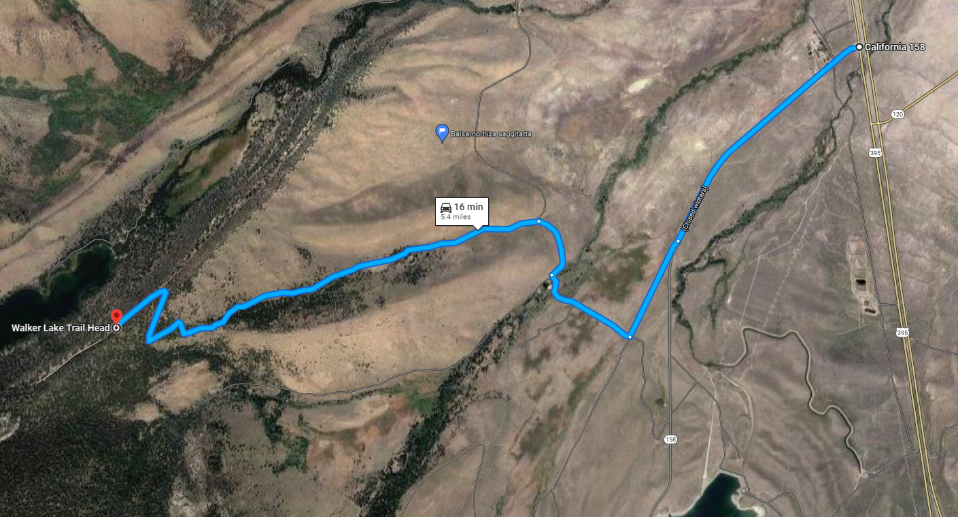

Think early about how you will organize your transportation needs to Yosemite Valley and leaving from Kootzagwae (Mono Lake Area).

Transportation options include YARTS Bus and the Eastern Sierra Transit Authority Bus. Carpooling with others is another option.

Important Things to Remember

- You are required to participate in one of the virtual orientation meetings before attending the Traditional Walk. If you miss an orientation, contact the Mono Lake – Yosemite Traditional Walk Committee immediately so that other arrangements can be made.
- Everybody must contribute to the Traditional Walk in some way. This can be by helping in the kitchen, sharing traditional knowledge, packing up items for the Pack Mules, or simply keeping a positive and supportive attitude and offering to help others where you can.
- Each youth must be chaperoned at all times. No more than 2 youth per adult, if the youth is not your child.
- Plan early!
- All registration packets must be returned to the Mono Lake – Yosemite Traditional Walk Committee by July 25, 2025.
- Notify the Mono Lake-Yosemite Traditional Walk Committee of any change of plans, no matter how late the change, so appropriate adjustments can be made in the planning process.
- No pets! The National Park Service will not allow pets into the backcountry. If you bring a pet, you cannot join the Traditional Walk. The National Park Service is FIRM on this. There are no exceptions!!
- Use this opportunity to meet new people.
- Focus on your traditional heritage and learn as much as you can about traditional ways of seeing the land, stars, plants, wildlife, water, fire, other people, and yourself.
- STAY SAFE AND HAVE FUN!

Safety Guidelines for Thunderstorms
Copied from the National Wildfire Coordinating Group 2025 Incident Response Pocket Guide
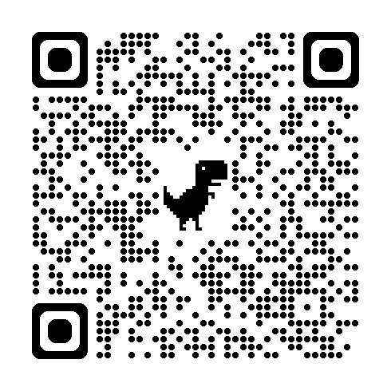
Approaching thunderstorms may be noted by a sudden reverse in wind direction, a noticeable rise in wind speed, and a sharp drop in temperature. Rain, hail, and lightning occur only in the mature stage of a thunderstorm.

Situation Awareness: Sound waves move at different rates based on atmospheric conditions. Take the storm precautions below as soon as you hear thunder, not when the storm is upon you. Do not resume activity in exposed areas until 30 minutes after storm activity has passed.

Hazard Control:
• Take shelter in a vehicle or building if possible.

• If outdoors, find a low spot away from tall trees, wire fences, utility lines, and other elevated conductive objects. Pick a place that is not subject to flooding.

• If in the woods, move to an area with shorter trees.

• If only isolated trees are nearby, keep your distance twice the tree height.

• If in open country, crouch low with feet together, minimizing contact with the ground. You can use a pack to sit on, but never lie on the ground.

• If you feel your skin tingle or your hair stand on end, immediately crouch low to the ground. Make yourself the smallest possible target and minimize your contact with the ground.

• Don’t group together.

• Don’t stay on ridge tops, in wide open areas, or near ledges or rock outcroppings.

• Don’t operate landline telephones, machinery, or electric motors.

• Don’t handle metal hand tools or flammable materials in open containers.

Rules of Conduct & Behavior
Yosemite Valley – Kootzagwae Traditional Walk July 27 - August 2, 2025

I AGREE TO ABIDE BY THE FOLLOWING:
- I will be responsible for myself and my behavior.
- I will use appropriate language and model appropriate behavior.
- I will treat the land, all people, animals and equipment with the utmost care and respect.
- I will maintain a clean and environmentally friendly campsite.
- I will participate in the maintenance of the camp.
- I will always use environmentally safe practices in all places and at all times.
- I understand that this is an alcohol/drug free event and will not bring, use, or distribute alcohol, marijuana, or drugs.
- I understand that if I do not do all of the above, I will leave the Traditional Walk as requested.
Parent Signature (if participant is a minor):

Signature:

Date:
Name (printed):

Registration Form
(Please fill out this form completely and send in by July 25, 2025)
Mailing Address:
Tribal Affiliation:
Name:
Email Address:
T-Shirt Size (check one): Adult: ☐ S ☐ M ☐ L ☐ XL ☐ XXL ☐ XXXL Child: ☐ S ☐ M ☐ L
Phone Number:
If under the age of 18, name of adult chaperone on the trip who is responsible for you:
Financial contributions or talent offerings to make the Traditional Walk possible: ☐
$
Talent/Skills:
☐
Choose the ways you will help maintain the camp (check all that apply):
☐ Haul Water ☐ Gather Wood ☐ Dig/Bury Community Toilet Pit ☐ Trash Pick Up ☐ EMT first responder ☐ First Aid/CPR ☐ Kitchen Help ☐ Transport Others and/or their gear ☐ Traditional Security ☐ Bear Watch ☐
Date you plan to start the Walk:
Other Suggestions:
Talent/Skills:
☐ Sunday, July 27th: Meet us at the Yosemite Indian Village on Sunday afternoon/evening.
Monday, July 28th: It is not possible to start the Walk as the Walkers are enroute to Snow Creek Campground.
☐ Tuesday, July 29th: If you are just starting the Walk, meet us Tuesday night at the west shore of Tenaya Lake.
☐ Wednesday, July 30th: Rest Day at Tenaya Lake. If you are just starting the Walk, meet us Wednesday night at the west shore of Tenaya Lake.
☐ Thursday, July 31st: If you are just starting the Walk, meet us Thursday night at the Tuolumne Meadows Campground.
Friday, August 1st: It is not possible to start the Walk as the Walkers are enroute to the Mono Pass campsite.
☐ Saturday, August 2nd: Optional, but if staying in Kootzagwae (Mono Lake) on Saturday night at the tribal lands campground and leaving Sunday or Monday morning, please check this box.
Transportation at the conclusion of the Traditional Walk from the Walker Lake Trailhead Campground (Check one):
☐ Walking ☐ Carpool from Walker Lake Trailhead ☐ Personal Vehicle ☐Bus (YARTS)

Are you on a special diet prescribed by a physician or allergic to any foods? ☐ Yes ☐ No. If you answered Yes regarding diet, please explain below.

ACTIVITY CONSENT FORM
The purpose of this form is for each participant over the age of 18 to provide their informed written consent to participate in the annual traditional Walk between Yosemite Valley and Kootzagwae (Mono Lake area) (“The Walk”) (direction alternates annually).
The Walk is approximately 50-60 miles of hiking over five (5) days, eating on the trail, camping at night, with the option to participate in various activities and ceremonies on route (e.g. sweat lodge ceremony at Tenaya Lake).
Name (First, Middle, Last):
Address:
Age during activity:
Birth date:
Zip Code:
State:
City:

INFORMED CONSENT, RELEASE AGREEMENT, AND AUTHORIZATION
I understand that participation in The Walk and related program activities involves the risk of personal injury, including death, due to the physical, mental, and emotional challenges in the activities offered. Information about those activities may be obtained from the activity coordinators. I also understand that participation in these activities is entirely voluntary and requires participants to follow instructions and abide by all applicable rules and standards of conduct.
With appreciation of the dangers and risks associated with The Walk and related programs and activities, including preparations for and transportation to and from the activity, I hereby fully and completely release and waive any and all claims for personal injury, death, or loss that may arise against the Mono Lake – Yosemite Traditional Walk Committee, any tribal officers, any tribal staff, any activity coordinators, and all employees, volunteers, related parties, or other organizations associated with any program or activity.
Participant’s Signature:
Additional emergency contact:
Email:
Date:
Phone Number:
Participant’s Printed Name:

ACTIVITY CONSENT FORM AND APPROVAL BY PARENTS OR LEGAL GUARDIAN
The purpose of this form is for parents and legal guardians to provide their informed written consent and approval for youth to participate in the annual traditional Walk between Mono Lake and Yosemite Valley (“The Walk”) (direction alternates annually). The Walk is approximately 50-60 miles of hiking over five (5) days, eating on the trail, camping at night, with the option to participate in various ceremonies on route (e.g. sweat lodge ceremony at Tenaya Lake).
Zip Code:
State:
City:
Address:
Age during activity:
Birth date:
Name (First, Middle, Last):

INFORMED CONSENT, RELEASE AGREEMENT, AND AUTHORIZATION
I understand that participation in The Walk and related program activities involves the risk of personal injury, including death, due to the physical, mental, and emotional challenges in the activities offered. Information about those activities may be obtained from the activity coordinators. I also understand that participation in these activities is entirely voluntary and requires participants to follow instructions and abide by all applicable rules and the standards of conduct. In case of an emergency involving my child, I understand that efforts will be made to contact me. In the event I cannot be reached, permission is hereby given to the medical provider to secure proper treatment, including hospitalization, anesthesia, surgery, or injections of medication for my child. Medical providers are authorized to disclose protected health information to the adult in charge and/ or any physician or health care provider involved in providing medical care to the participant. Protected Health Information/Confidential Health Information (PHI/CHI) under the Standards for Privacy of Individually Identifiable Health Information, 45 C.F.R. §§160.103, 164.501, etc. seq., as amended from time to time, includes examination findings, test results, and treatment provided for purposes of medical evaluation of the participant, follow-up and communication with the participant’s parents or guardian, and/or determination of the participant’s ability to continue in the program activities.
With appreciation of the dangers and risks associated with The Walk and related programs and activities, including preparations for and transportation to and from the activity, on my own behalf and/or on behalf of my child, I hereby fully and completely release and waive any and all claims for personal injury, death, or loss that may arise against the Mono Lake – Yosemite Traditional Walk Committee, any tribal officers, any tribal staff, any activity coordinators, and all employees, volunteers, related parties, or other organizations associated with any program or activity. NOTE: The Mono Lake-Yosemite Traditional Walk Committee and related individuals listed in the preceding sentence cannot continually monitor compliance of program participants or any limitations imposed upon them by parents or medical providers. List any restrictions imposed on a child participant in connection with programs or activities below and counsel your child to comply with those restrictions.
List participant restrictions, if any:
Confirm that participant is physically, mentally, and emotionally prepared and able to participate in program activities: ☐ Yes, my child is able to participate ☐ No, my child is not able to participate
Date:
Participant’s Signature:
Parent/guardian Phone Number:
Parent/guardian Printed Name:

Parent/guardian signature:
Parent/guardian email:
Parent & Chaperone Agreement
(Fill this agreement out if you will not be accompanying your child on the Walk)

- I, , acknowledge that, ,
(parent) (adult chaperone)

will supervise and be responsible for my child, at all times, for the duration of the Traditional Walk.
- I agree to attend the mandatory orientation with my child
- I further agree that if my child needs to leave the Traditional Walk at any time, I will be responsible for transporting my child back home.

Additional emergency contact (if parent unreachable):
Parent/guardian email:
Parent/guardian Phone Number:
Parent/guardian Signature:
Date:
Chaperone’s email:
Date:
Chaperone’s Signature:
Chaperone’s Phone Number:

